**Ideation Phase**

**Empathize and Discover**

|  |  |
| --- | --- |
| **Date** | 18-10-2023 |
| **Team ID** | Team-591653 |
| **Project Name** | Online Fraud Detection |

**Empathy Map Canvas:**

In our empathy map centered on online fraud detection testing, our focus lies on a persona intricately linked with this subject matter. It's crucial to focus on personas intricately linked with the subject matter when it comes to online fraud detection testing. Online fraudulent transactions are a significant criminal violation that costs people and financial institutions billions of dollars every year. Financial institutions play a crucial role in detecting and preventing fraudulent acts, and machine learning algorithms provide a proactive way to prevent online transaction frauds with high accuracy. Online transaction fraud is a simple and easy target, especially with the increase in the number of online payment methods used in e-commerce and other online sites, raising the danger of online fraud. With the rise in fraud rates, machine learning approaches can be used to identify and evaluate fraud in online transactions. The primary goal of this project is to implement supervised machine learning models for fraud detection, analyzing prior transaction information, and classifying transactions into distinct groups based on the type of transaction. Various classifiers are trained independently, and models are assessed for correctness. The classifier with the highest rating score can then be picked as one of the best approaches for predicting fraud.

**Empathy Map:**

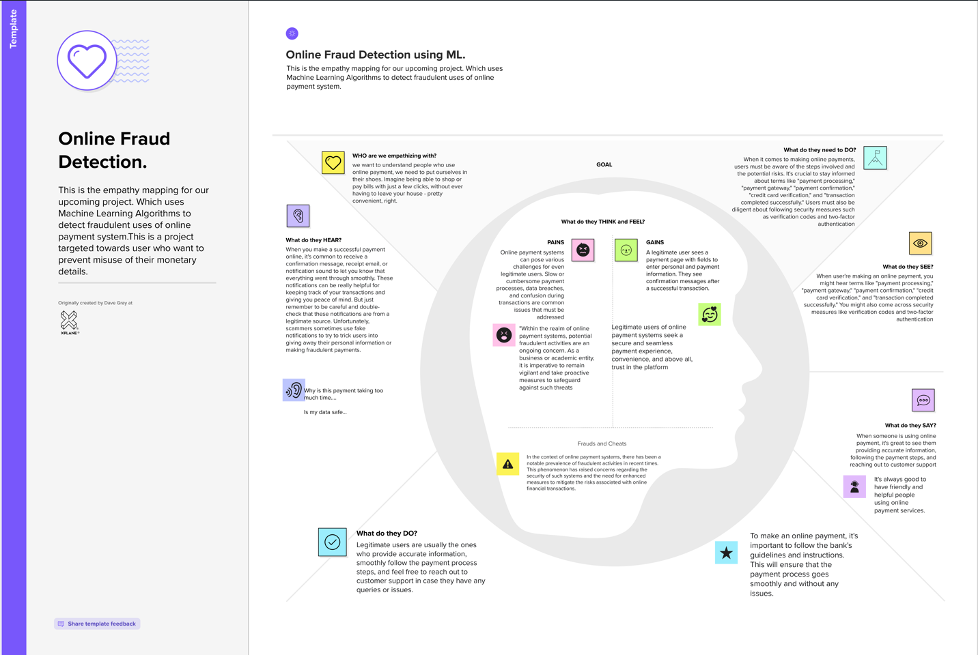

**URL - Empathy Map:** <https://shorturl.at/GO158>

**Ideation Phase**

**Brainstorm and Idea Prioritization**

|  |  |
| --- | --- |
| **Date** | 18-10-2023 |
| **Team ID** | Team-591653 |
| **Project Name** | Online Fraud Detection |

A group of people come up with a list of prospective ideas, proposals, or solutions during a brainstorming session for a project or problem.

**Brainstorming:**

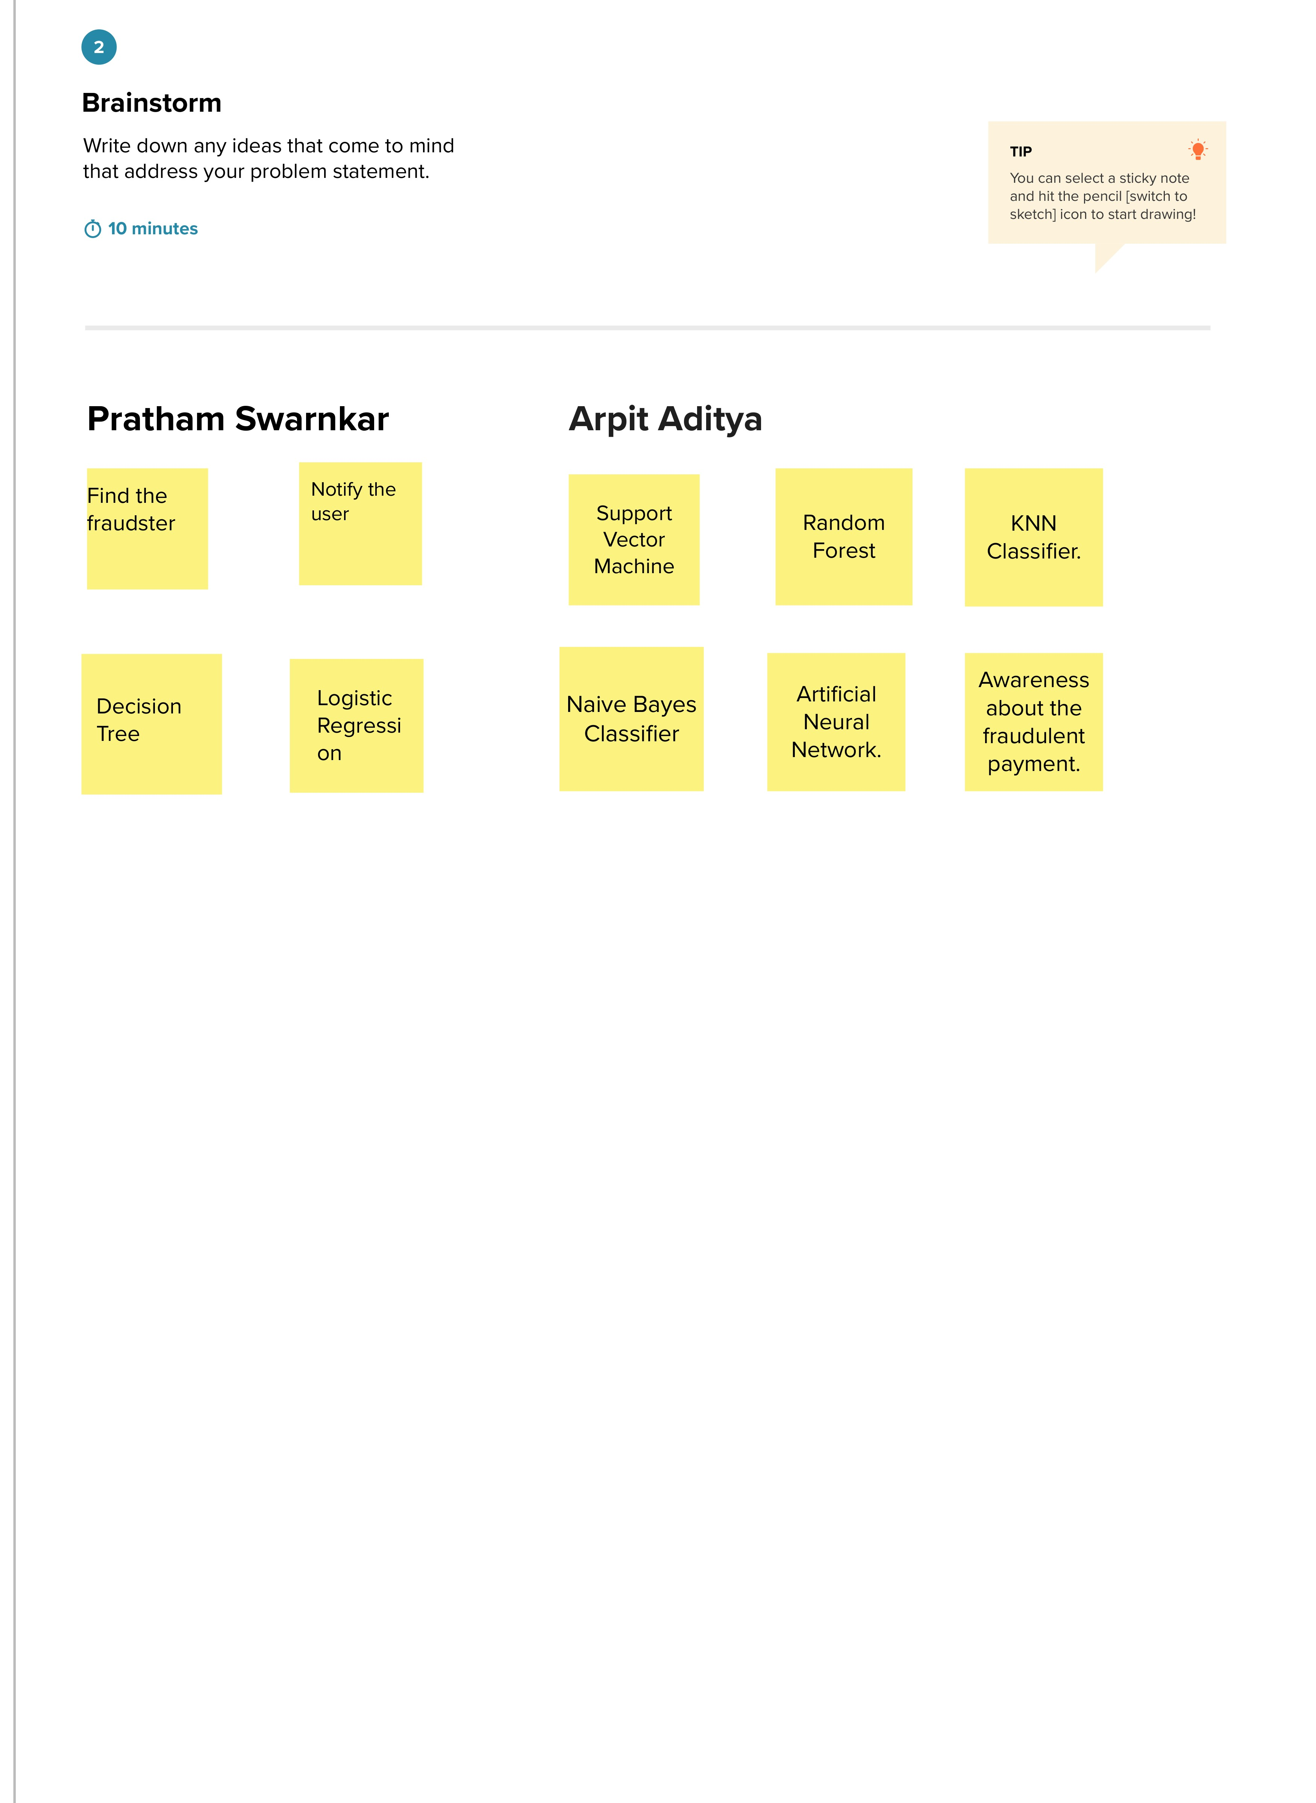

After an extensive and thorough evaluation, we have decided and successfully identified and selected the final ideas for our project. Our selection criteria have been carefully honed to prioritize the ideas' significance and feasibility, and we are confident that this process has allowed us to choose ideas that not only hold immense potential but are also realistic and actionable. We will delve into the factors that influenced our decision-making, providing you with a comprehensive understanding of how we arrived at these definitive choices.

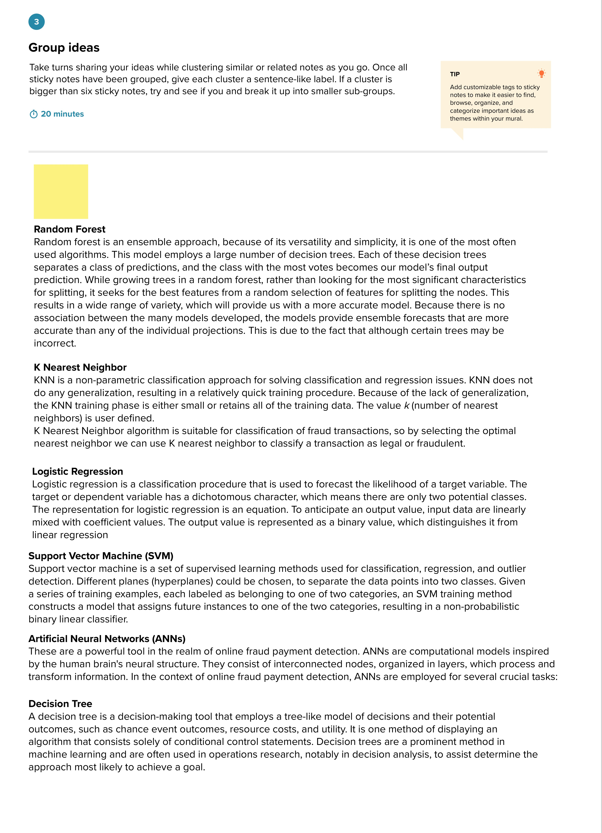

**Prioritization of ideas:**

In order to decide which ideas should be implemented or pursued first, it is necessary to rank or evaluate them according to specified criteria, such as practicality, impact, cost, or strategic relevance.

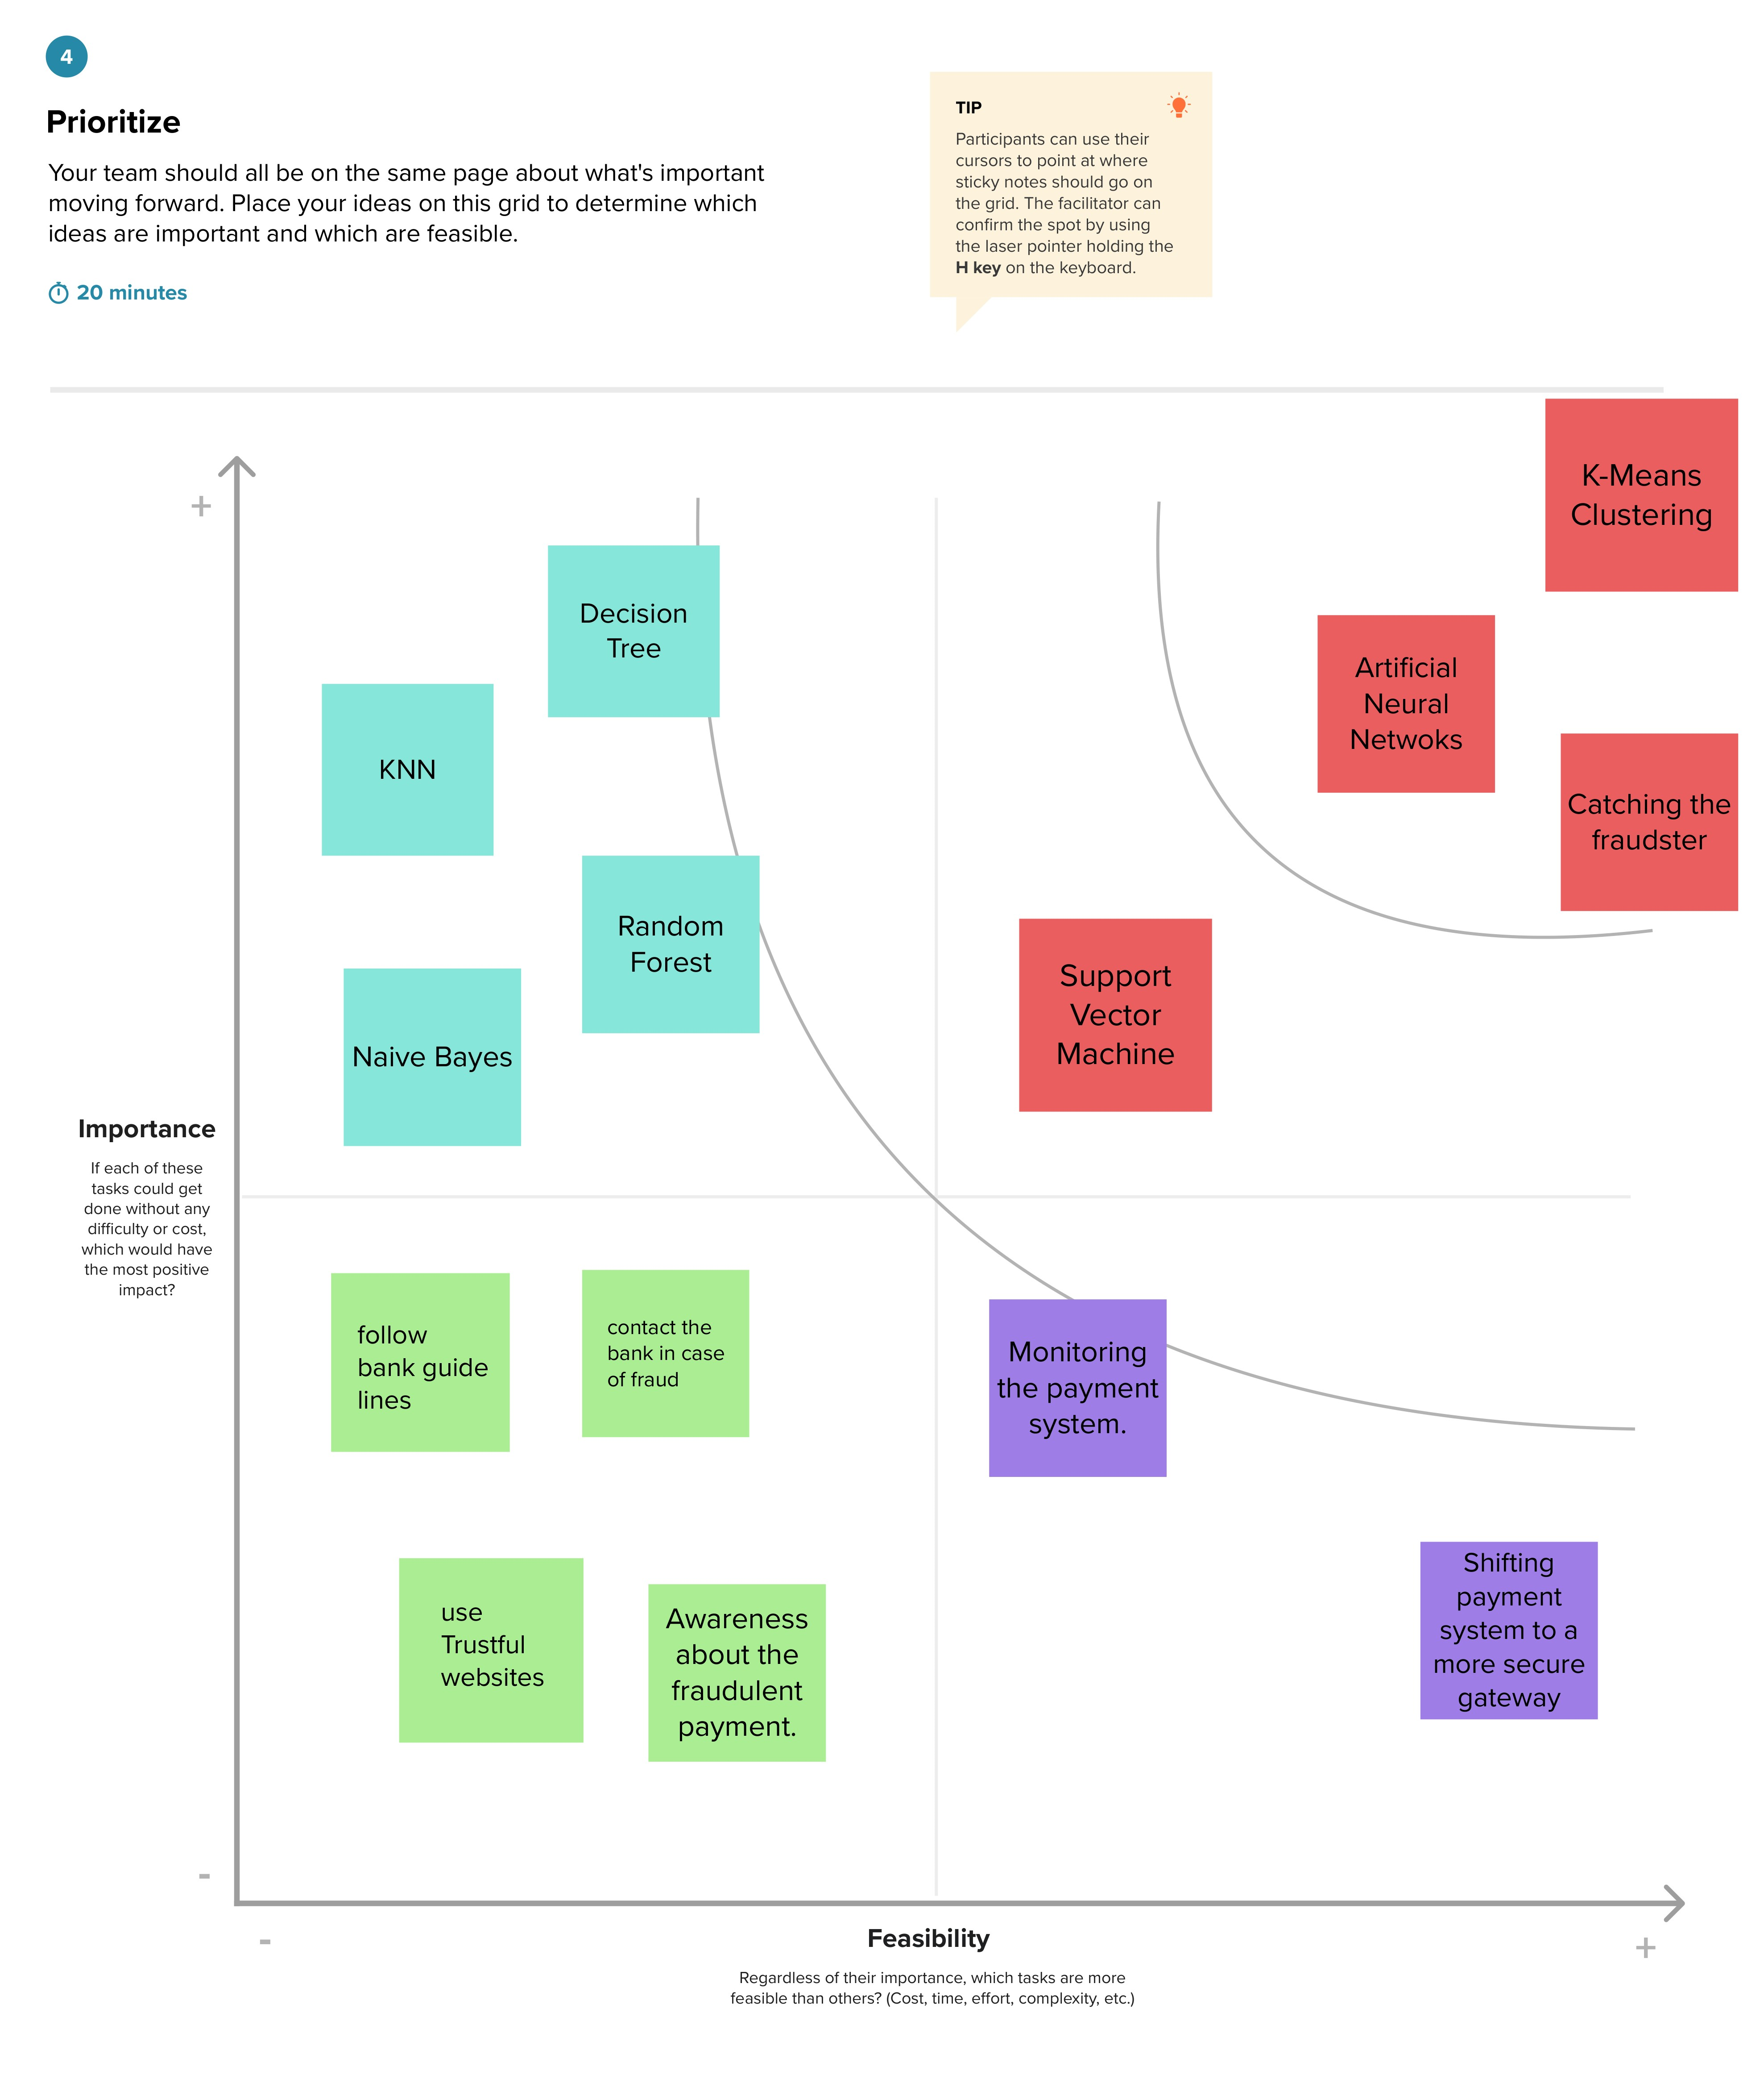

**URL - Brainstorming and Idea Prioritization:** <https://shorturl.at/fsFX5>